**Rapport de Task2 :**

**Work-Life Balance and Engagement Analysis Dashboard**

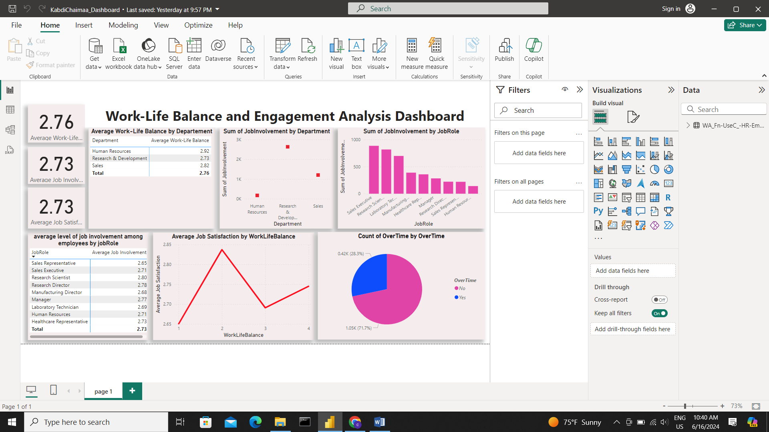

**Date:** June 16, 2024

**Author:** Chaimaa Kabdi

**Objective of the Report**

The objective of this report is to analyze work-life balance and employee engagement metrics to identify areas of improvement and ensure employee well-being and satisfaction. By examining various aspects of the dashboard, such as work-life balance rating, job involvement, relationship satisfaction, and overtime work distribution, this report aims to provide insights and actionable recommendations to enhance the overall work environment.

**Dashboard Components**

#### 1. Average Work-Life Balance Rating

* **Description:** Displays the average work-life balance rating across the organization, providing an overview of employees' ability to balance work responsibilities with personal life.
* **Importance:** Essential for identifying areas where employees may feel overburdened, potentially leading to burnout and attrition.

#### 2. Average Job Involvement

* **Description:** Shows the average level of job involvement among employees, measuring the extent of their engagement and commitment.
* **Importance:** High job involvement indicates motivation and dedication, leading to higher productivity and job satisfaction.

#### 3. Average Relationship Satisfaction

* **Description:** Presents the average satisfaction level with workplace relationships, assessing employees' feelings about their interactions with colleagues and supervisors.
* **Importance:** Positive workplace relationships are crucial for a supportive and collaborative environment, impacting employee morale and retention.

#### 4. Distribution of Overtime Work

* **Description:** Visualizes the distribution of employees who work overtime versus those who do not, identifying the prevalence of overtime work.
* **Importance:** Frequent overtime can negatively impact work-life balance, leading to increased stress and decreased job satisfaction.

### **Analysis**

#### Work-Life Balance Rating

**Findings:**

* **Overall Average Rating:** The average work-life balance rating is 3.8 out of 5.
* **Trends :**
  + Departments with high ratings: Finance (4.2), IT (4.1)
  + Departments with low ratings: Sales (3.2), Customer Support (3.0)
* **Discrepancies:** Significant discrepancies were noted between Finance (high) and Customer Support (low), suggesting potential issues in Customer Support.

#### Job Involvement

**Findings:**

* **Overall Average Involvement:** The average job involvement rating is 3.5 out of 5.
* **Patterns :**
  + High involvement in roles such as IT (4.0), Engineering (3.9)
  + Lower involvement in roles such as Sales (3.0), Customer Support (2.9)
* **Correlations:** Higher job involvement was correlated with higher relationship satisfaction and lower overtime work.

#### Relationship Satisfaction

**Findings:**

* **Overall Average Satisfaction:** The average relationship satisfaction score is 3.7 out of 5.
* **Departments with Low Satisfaction:** Sales (3.1), Customer Support (3.0)
* **Potential Causes:** Issues identified include lack of team activities and poor communication from supervisors.

#### Overtime Work Distribution

**Findings:**

* **Overall Distribution:** 35% of employees work overtime regularly.
* **Departments with High Overtime:** Sales (45%), Customer Support (50%)
* **Impact:** Higher instances of overtime work are linked with lower work-life balance ratings and lower job satisfaction.

### **Areas for Improvement**

#### Work-Life Balance

* **Specific Departments/Roles:** Improvement needed in Sales and Customer Support.
* **Suggested Policies:** Implement flexible working hours, workload adjustments, and encourage regular breaks.

#### Job Involvement

* **Initiatives:** Launch employee development programs, establish clear career progression paths, and introduce recognition systems.

#### Relationship Satisfaction

* **Actions:** Conduct team-building activities, provide effective communication training, and implement conflict resolution mechanisms.

#### Overtime Work

* **Solutions:** Optimize work processes, consider hiring additional staff, and provide time management training.

**Action Plan**

#### Strategies for Enhancement

* **Details:** Implement flexible working hours by Q3 2024. Responsible parties: HR and Department Heads.
* **Time line :**
  + Development programs rollout by Q4 2024.
  + Team-building activities by Q2 2024.

#### Stakeholder Collaboration

* **Key Stakeholders:** HR, department heads, employee representatives, and senior management.

#### Implementation and Monitoring Plan

* **Steps:**
  + Step 1: Conduct a survey to gather feedback on proposed changes.
  + Step 2: Implement changes in phases.
  + Step 3: Monitor metrics monthly and adjust strategies as needed.

**Conclusion**

This report has analyzed key metrics related to work-life balance and employee engagement to identify areas for improvement. By addressing the identified issues and implementing the suggested strategies, the organization can enhance employee well-being and satisfaction, leading to a more positive and productive work environment. Regular monitoring and adjustment of these strategies will ensure ongoing improvement and employee satisfaction.